


IX Series Specifications

Scope
- This specification identifies the minimum requirements for diaphragm metering pumps.

Reference codes and standards
  - Pumps shall comply with the latest editions of the following codes and standards:

UL Standard 778

NEMA 4X (IP65)
Hydraulic Institute Standards

National Electric Code

Definitions
  - Mechanically Actuated Diaphragm Pump - a positive displacement diaphragm-metering pump in which there is a direct coupling mechanism between the diaphragm and the motor.

General
  - Output volume shall be adjustable while pump is in operation.
  - Weight of pump as installed shall not exceed 43 pounds.
  - Pump shall fit within a rectangular volume 19” long by 8” wide by 20” high.
  - The pump shall be designed such that it will not gas-lock up to maximum rated pressure, eliminating need for secondary gas elimination devices .

Drive
  - The mechanically actuated diaphragm metering pump mechanism shall be totally enclosed with no exposed moving parts.
  - The p ump drive shall utilize a Brushless DC variable speed motor (BLDC) directly coupled to an integrated gearset. The full rotation shall be converted to a reciprocating motion by means of a cam.
  - A diaphragm shall be mechanically connected to the pump drive. There shall be no hydraulic oil backing of the diaphragm.
  - The pump drive shall be factory lubricated and sealed. The drive shall be maintenance free for life.
  - The pump drive shall utilize a spring-assist discharge design, providing extra spring force during the discharge stroke.
  - The diaphragm stroke length is not adjustable and always operates at maximum throughout the entire operation range.
  - Metering pump shall be capable of pumping a maximum of (q) GPH against a maximum pressure of (p) PSI. (q and p from Table 1)
  - The interface control unit, internal electronics, input and output connections, and main power shall all be located opposite the liquid end. The interface control unit shall be protected by a clear polycarbonate cover.
  - The control unit can be mounted in several orientations to facilitate ease of access and pump mounting. Mounting positions can be adjusted in the field.
  - Average power consumption shall not exceed 19 watts in the IXB drive, 62 watts in the IXC drive, and 110 watts in the IXD drive - all under full load conditions.
  - The pump shall be capable of operating within a voltage range of 100-240VAC.
  - The pump shall have a discrete input for either a digital PULSE or ANALOG input signal for an external proportional control signal.
  - The pump shall have a discrete digital input to stop or start pump operation.
  - The pump shall have a discrete digital input for a pre-stop (level) indication.
  - The pump shall have a discrete digital input for a programmable auxiliary input signal, overriding existing pump operation and force pump operation at a preprogrammed output.
  - The pump shall be equipped with one programmable mechanical Output relay capable of 250VAC/2A that can be activated by a stop, pre-stop, interlock, leak detection, motor overload, batch complete, or drive error. Programming of the mechanical relay output and relay state condition are done using push buttons.
  - The pump shall be equipped with one programmable Photo-MOS Output relay capable of 24V/0.1A that can be activated by a stop, pre-stop, interlock, leak detection, motor overload, batch complete, drive error, or set for volume proportional pulse output. Programming of the relay output and relay state condition are done using push buttons.
  - The pump shall have a 12VDC/30mA power supply output.
  - The pump shall have a programmable 0/4-20mA output control signal to relay output proportional to flowrate of the pump.
  - Input and Output connections shall be made with standard M12 DIN connections and square mini-DIN format for outputs.
  - The liquid end and ball-check valve cartridge design shall provide ease of maintenance.
  - Valve cartridges and pump heads shall be designed to ensure assembly is possible in only one direction. Cartridges shall be clearly marked for visual orientation.
  - Valve cartridges shall be double-ball design on both suction and discharge in pumps below 15GPH and single-ball design in larger pumps.
  - IXB pumps shall be able to use their removeable mounting base as a wall-mounting bracket, securing the pump to a vertical surface.

Electronic Control
  - Pump shall be able to be stopped, started, programmed, operated, and manually primed by means of a readily accessible keypad with seven push buttons and a backlit, two-line, 16-character liquid crystal display.
  - Control of pump speed shall be selectable between manual and external by means of push buttons.
  - In manual mode, pump speed shall be adjustable from zero to maximum output by means of push buttons.
  - The control unit will have a multicolor LED for indicating pump status (alarm, waiting, stopped, running, pre-stop, operation).
  - Pump shall be able to display the pump’s output in gallons per hour or liters per hour. Selection of gallons or liters is chosen using pushbuttons.
  - The keypad shall be lockable with a programmable PIN to prevent tampering.
  - Pumps shall be factory calibrated at maximum flowrate and pressure. An easy calibration routine in the pump shall be available for field adjustments of pump output based on drawdown results.
  - In external Analog mode, the pump shall accept a flexible 0/4-20 mA control signal from external equipment and operate at a volume that is proportional to the signal level. The slope and zero offset of the pump’s response shall be operator programmable by means of push buttons or selectable from four pre-programmed slopes.
  - In external Pulse control mode, the pump shall respond to a pulse signal from external equipment such that a determined volume is delivered per incoming pulse. The volume per pulse shall be operator programmable by means of push buttons. The pump output is then determined from the frequency of incoming pulses.
  - In external Batch control mode, the pump will output a larger programmed volume with each incoming pulse. Volume of output is programmed by means of push buttons. A pulse memory setting will allow pulses to be stored or ignored during operation.
  - In external interval Batch control mode, the pump will perform a Batch control mode program, at programmed time intervals, repeating until stopped. An external digital signal or push buttons shall be used to start the interval batch cycle.
  - The pump shall include a priming function that enables the pump to operate at full speed without changing the programmed values or control mode.
  - The logic of the inputs and the output relays are programmable normally open or normally closed.
  - Pump shall retain data relating to pump operation including, operation time, total volume pumped, number of times powered on, and total powered on time. This data can be viewed on the pump or cleared by means of push buttons.
  - The pump shall contain integral Diaphragm Leak Detection behind the diaphragm with all wiring being internal. Output 1 is programmed for leak detection alarm by default but is user-configured by means of keypad push buttons.
  - Pumps shall continuously monitor for over-pressurization and motor overload conditions, stopping pump operation when reached. An auto restart will occur five times before shutting down, requiring a user restart. Overload condition alarm can be programed as an output for alarm monitoring.
  - Suction speed setting can be user-programmed from 100% to 75%, 50%, or 25% to compensate for various chemical and plumbing conditions and maintain optimal pumping reliability.
  - A programmable maximum flow rate setting shall be provided to limit maximum output capability of the pump and protect from over-feeding.
  - Pump shall have a maintenance mode to facilitate easy and proper diaphragm replacement.
  - The display language shall be selectable from six languages including English, Spanish, French, and German.

Materials of construction
  - Pump housing shall be made of chemically resistant, fire retardant and UV protected Polyphenylene Ether (PPE). The pump housing will completely enclose the electronics, motor and drive mechanism.
  - Pump enclosure rating shall be to IP65 and NEMA 4X standards.
  - A PTFE diaphragm shall facilitate mechanical pumping of process media. EPDM and mesh backers may be used to provide reinforcement to the PTFE diaphragm in larger sized pumps.
  - All exposed metal fasteners shall be 316 stainless steel.
  - Liquid end materials shall be as shown in Table 2.

Tests
  - All pumps shall pass manufacturer’s standard inspection and performance tests.

Tables

Table 1 Capacity/Pressure Rating

Model | Capacity Range  GPH (LPH) | Max Pressure  PSI (MPa) | Average Power Consumption | Current  AMPS | Connection Size
 |  |  |  |  | TC/TE | S6
IX-B007 | 0.002-1.98  (0.0075 - 7.5) | 247*  (1.7) | 17W | 0.4A | 1/2" MNPT | 3/8” FNPT
 |  |  |  |  | 3/8" x 1/4" TUBING | 3/8” FNPT
 |  |  |  |  | 1/2" ANSI 150Lb FLANGE
IX-B015 | 0.004-3.96  (0.015 - 15) | 145  (1.0) | 17W | 0.4A | 1/2" MNPT | 3/8” FNPT
 |  |  |  |  | 3/8" x 1/4" Tube | 3/8” FNPT
 |  |  |  |  | 1/2" ANSI 150Lb FLANGE
IX-B030 | 0.008-7.93  (0.03 - 30) | 87  (0.6) | 19W | 0.5A | 1/2" MNPT | 3/8” FNPT
 |  |  |  |  | 3/8" x 1/4" Tube | 3/8” FNPT
 |  |  |  |  | 1/2" ANSI 150Lb FLANGE
IX-B045 | 0.012-11.89  (0.045 - 45) | 58*  (0.4) | 19W | 0.5A | 1/2" MNPT | 3/8” FNPT
 |  |  |  |  | 3/8" x 1/4" Tube | 3/8” FNPT
 |  |  |  |  | 1/2" ANSI 150Lb FLANGE
IX-C060 | 0.02 - 15.8  (0.08 - 60) | 145  (1.0) | 62W | 0.8A | 1/2" MNPT
 |  |  |  |  | 1/2" ANSI 150Lb FLANGE
IX-C150 | 0.05 - 39.6  (0.2 - 150) | 58  (0.4) | 62W | 0.8A | 3/4” MNPT
 |  |  |  |  | 3/4" ANSI 150Lb FLANGE
IX-D150 | 0.05 - 39.6  (0.2 - 150) | 145  (1.0) | 110W | 1.3A | 3/4” MNPT
 |  |  |  |  | 3/4" ANSI 150Lb FLANGE
IX-D300 | 0.1 - 79.2  (0.4 - 300) | 73  (0.5) | 110W | 1.3A | 1” MNPT
 |  |  |  |  | 1" ANSI 150Lb FLANGE

Table 2 Materials of Construction
Material symbol |  | TC | TE | S6
Part | Pump head | PVDF |  | 316SS
Part | Valve ball | CE | CE | 316SS
Part | Valve seat | FKM | EPDM | 316SS
Part | O ring | FKM | EPDM | -
Part | Valve gasket | PTFE
Part | Diaphragm | PTFE*

CE Alumina ceramic EPDM Ethylene propylene diene monomer
FKM Fluoroelastomer PTFE Polytetrafluoroethylene
PVDF Polyvinylidenefluoride SS316 316 stainless steel
NOTE: PTFE Diaphragm uses EPDM reinforcement backer in IX-C/D

DIMENSIONS

■ IX-(B007/B015/B030/B045) (TC/TE) N

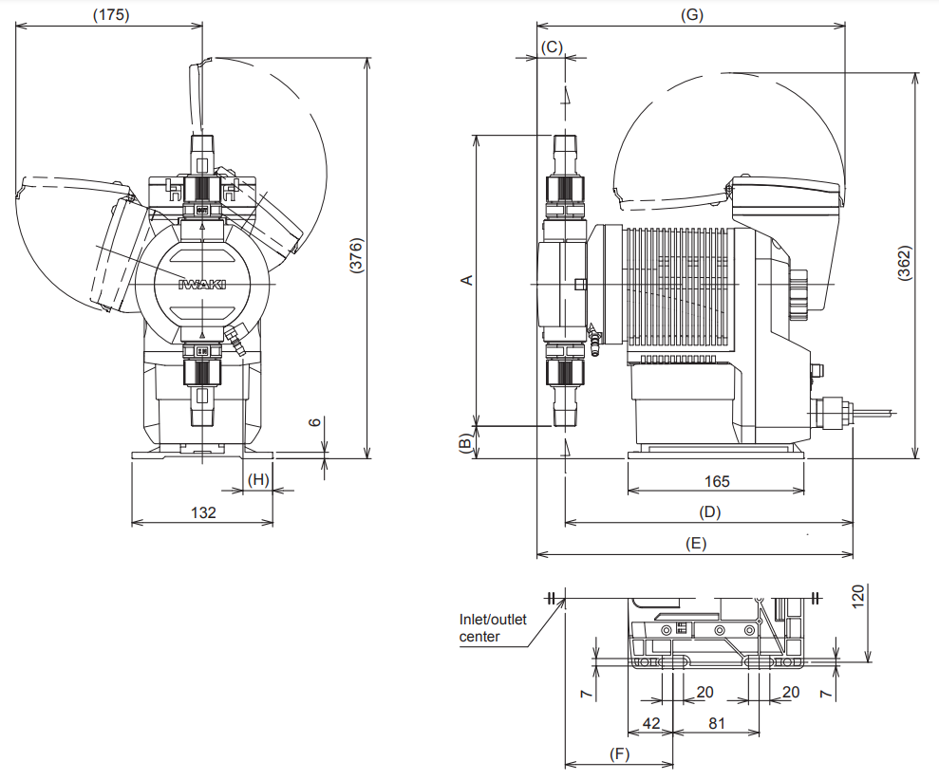

 | A | B | C | D | E | F | G | H
IXB007 | 240 | 45 | 24.3 | 267 | 291 | 98 | 284 | 29
IXB015 | 249 | 41 | 24.3 | 267 | 291 | 98 | 284 | 29
IXB030/045 | 273 | 30 | 26.4 | 270 | 296 | 101 | 289 | 28
All dimensions are in mm

■ IX-(B007/B015/B030/B045) (TC/TE) T

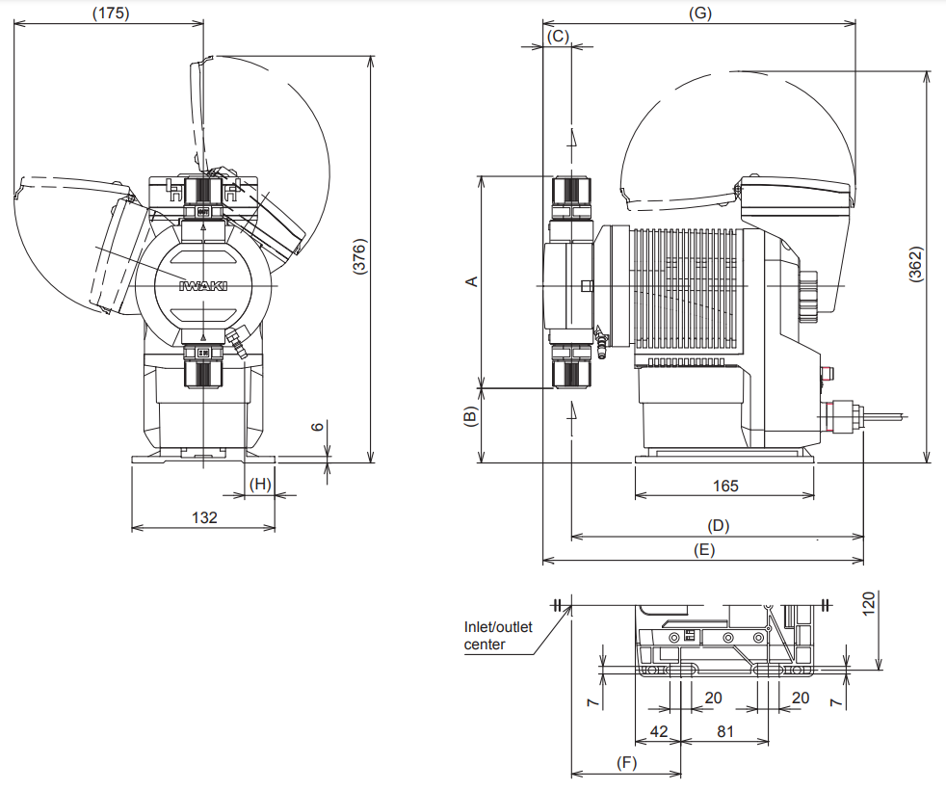

 | A | B | C | D | E | F | G | H
IXB007 | 168 | 81 | 24.3 | 267 | 291 | 98 | 284 | 29
IXB015 | 177 | 77 | 24.3 | 267 | 291 | 98 | 284 | 29
IXB030/045 | 201 | 66 | 26.4 | 270 | 296 | 101 | 289 | 28
All dimensions are in mm

■ IX-(B007/B015/B030/B045) (TC/TE) FA

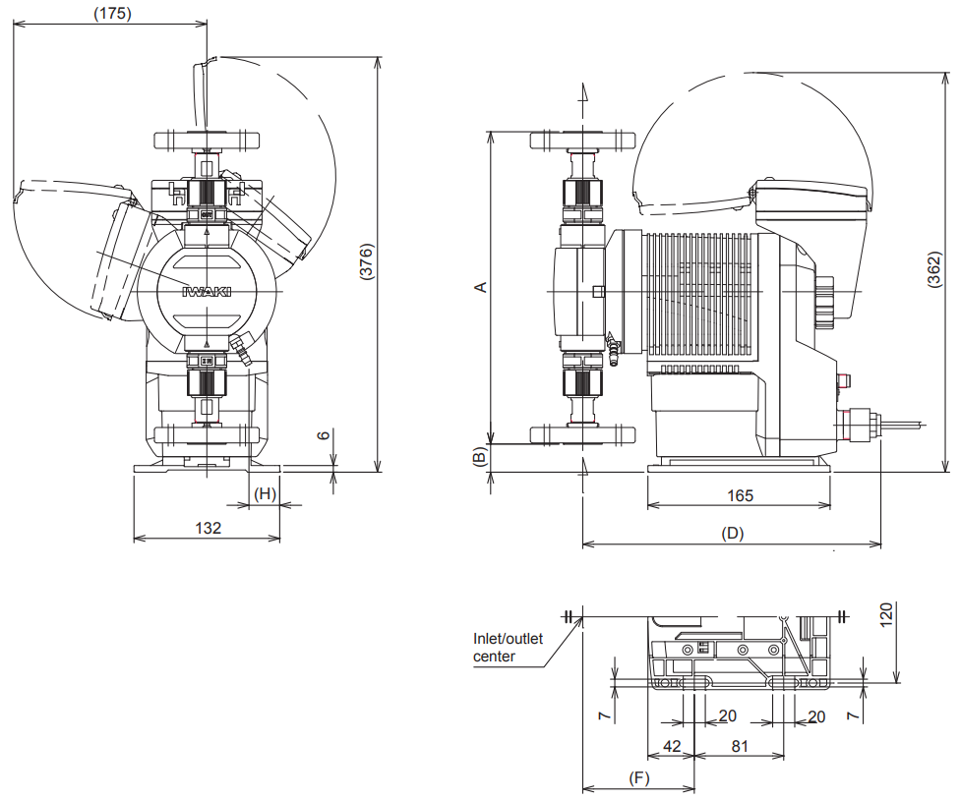

 | A | B | C | D | E | F | G | H
IXB007 | 250 | 40 | - | 267 | - | 98 | - | 29
IXB015 | 259 | 36 | - | 267 | - | 98 | - | 29
IXB030/045 | 283 | 25 | - | 270 | - | 101 | - | 28
All dimensions are in mm

■ IX-(B007/B015/B030/B045) S6 N

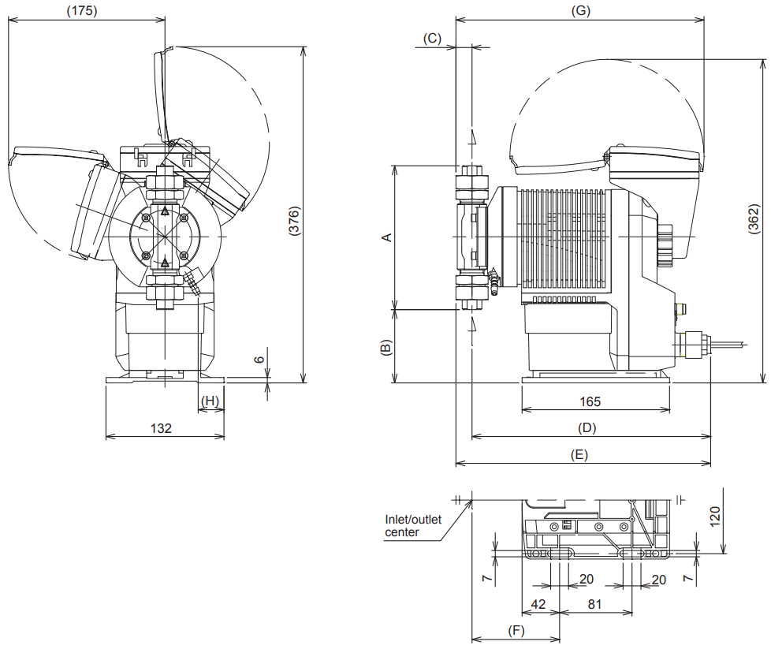

 | A | B | C | D | E | F | G | H
IXB007/015 | 161 | 82 | 18 | 267 | 285 | 95 | 278 | 29
IXB030/045 | 177 | 72 | 19 | 270 | 289 | 97 | 281 | 28
All dimensions are in mm

■ IX-(B007/B015/B030/B045) S6 FA

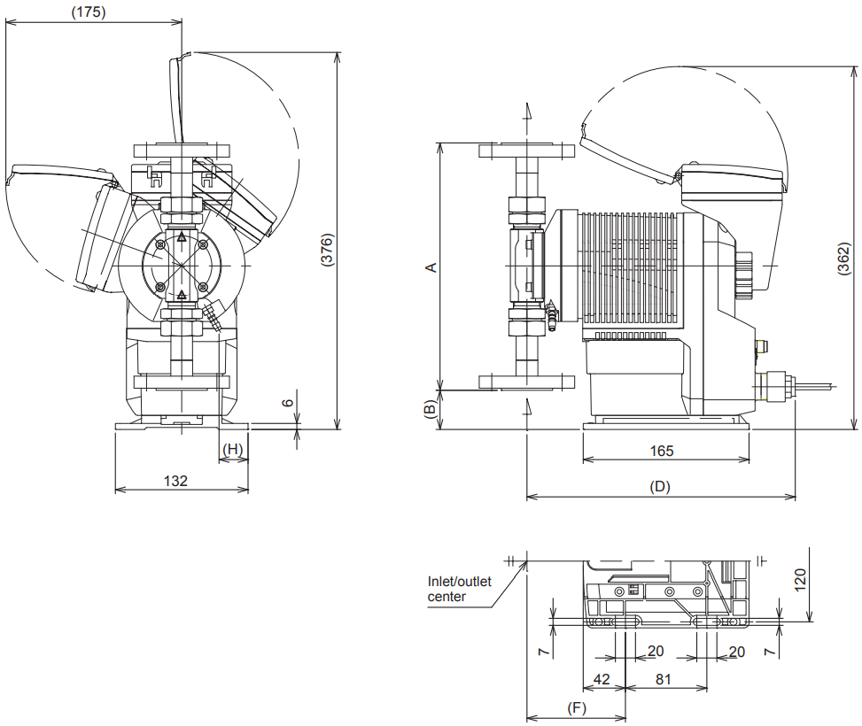

 | A | B | C | D | E | F | G | H
IXB007/015 | 247 | 39 | - | 267 | - | 95 | - | 29
IXB030/045 | 263 | 29 | - | 270 | - | 97 | - | 28
All dimensions are in mm

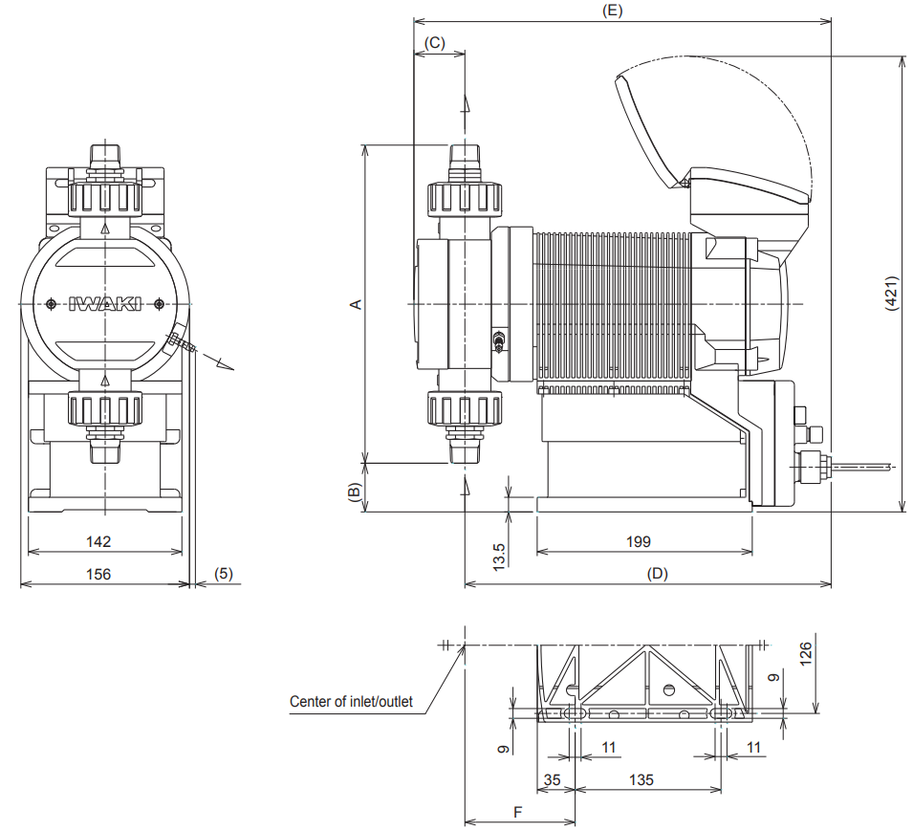
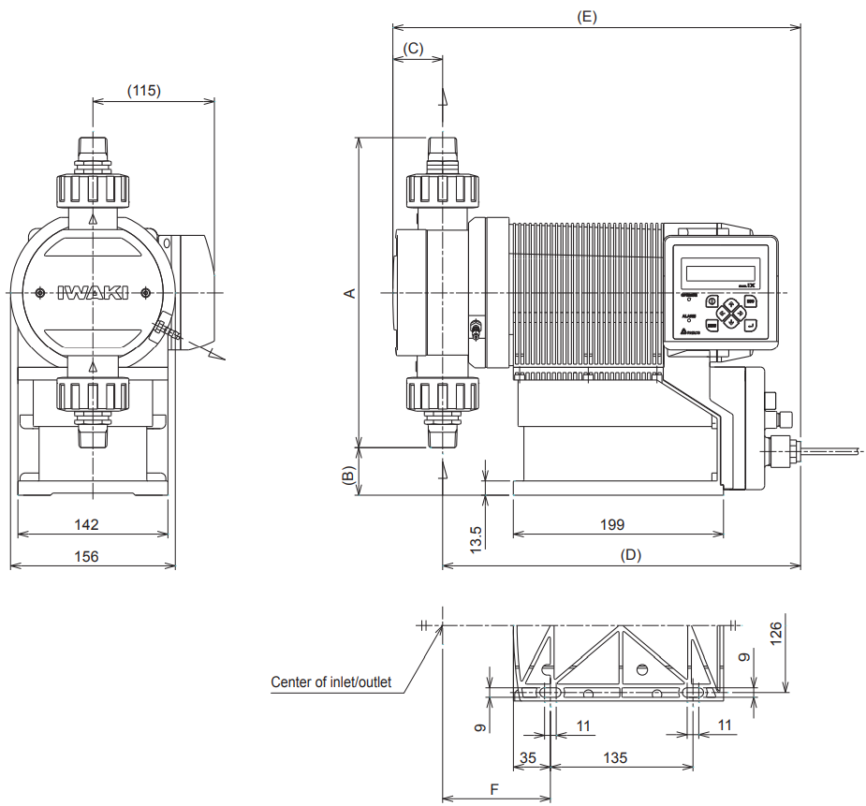
■ IX-(C060/C150)
(TC/TE) N

TB Mounting

RF Mounting

 | A | B | C | D | E | F
IX-C060 | 325 | 30 | 35 | 340 | 375 | 103
IX-C150 | 294 | 45 | 47 | 339 | 386 | 103
All dimensions are in mm

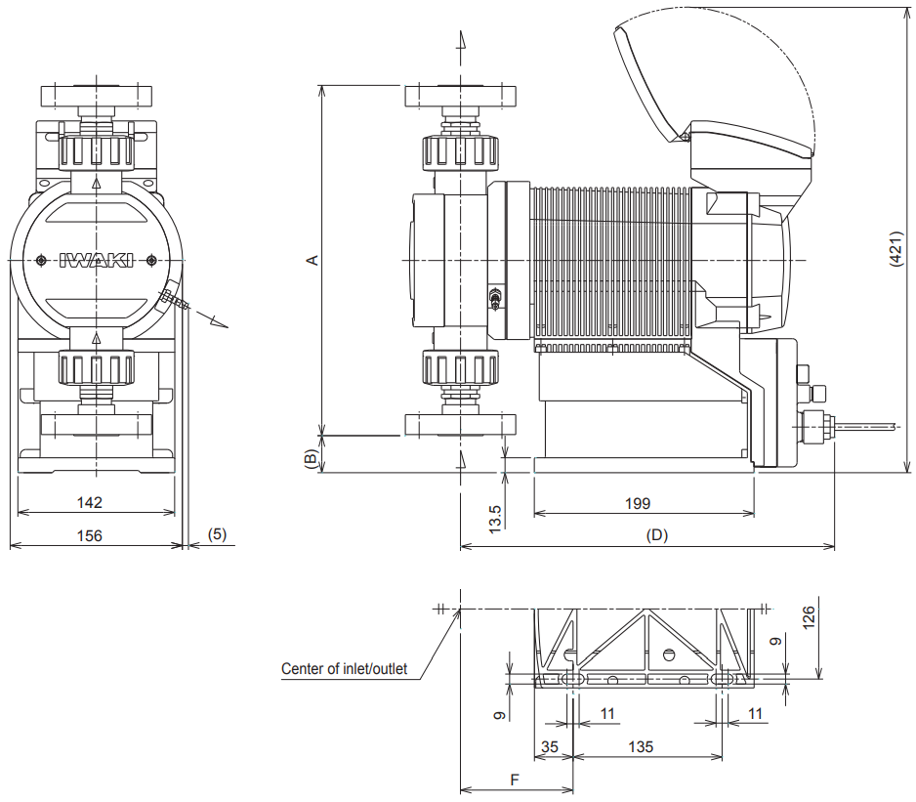
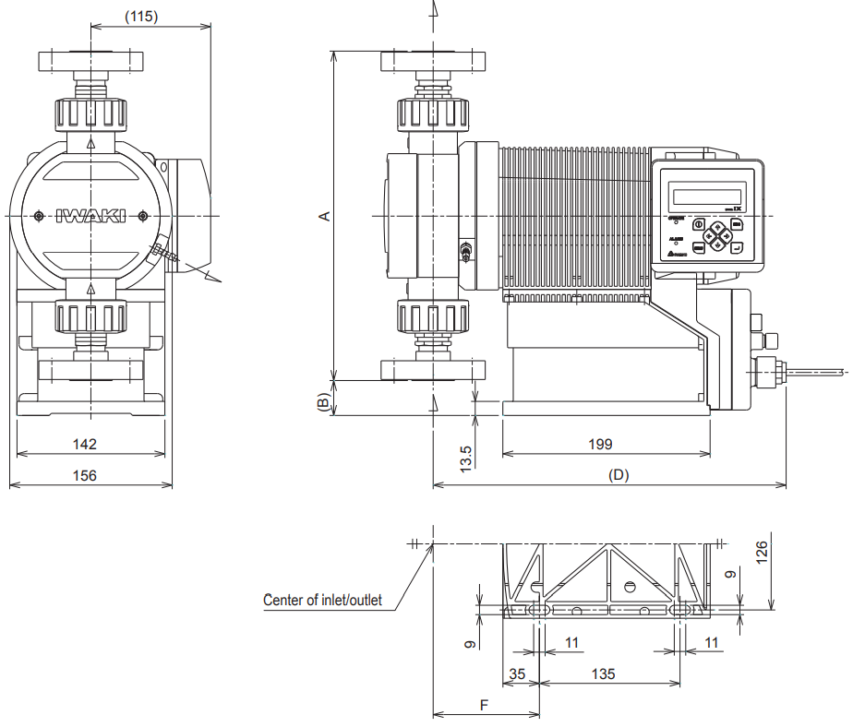
■ IX-(C060/C150)
(TC/TE) FA

TB Mounting

RF Mounting

 | A | B | C | D | E | F
IX-C060 | 335 | 25 | - | 340 | - | 103
IX-C150 | 317 | 34 | - | 339 | - | 102
All dimensions are in mm

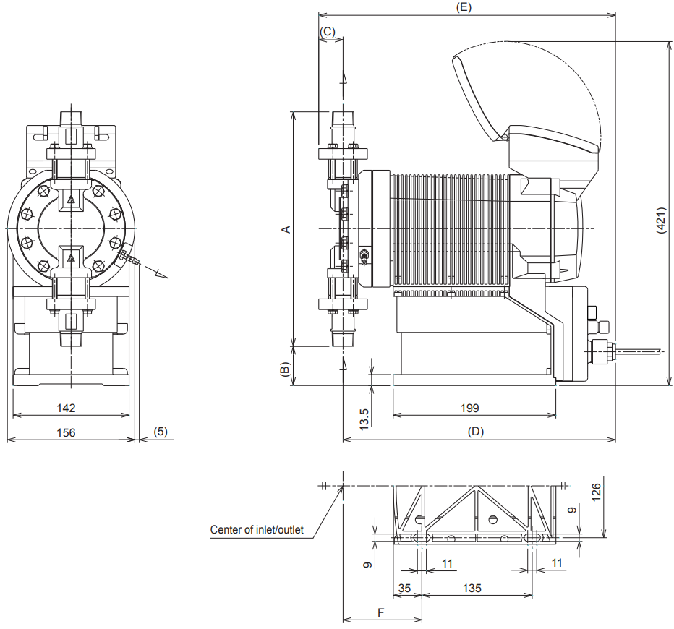
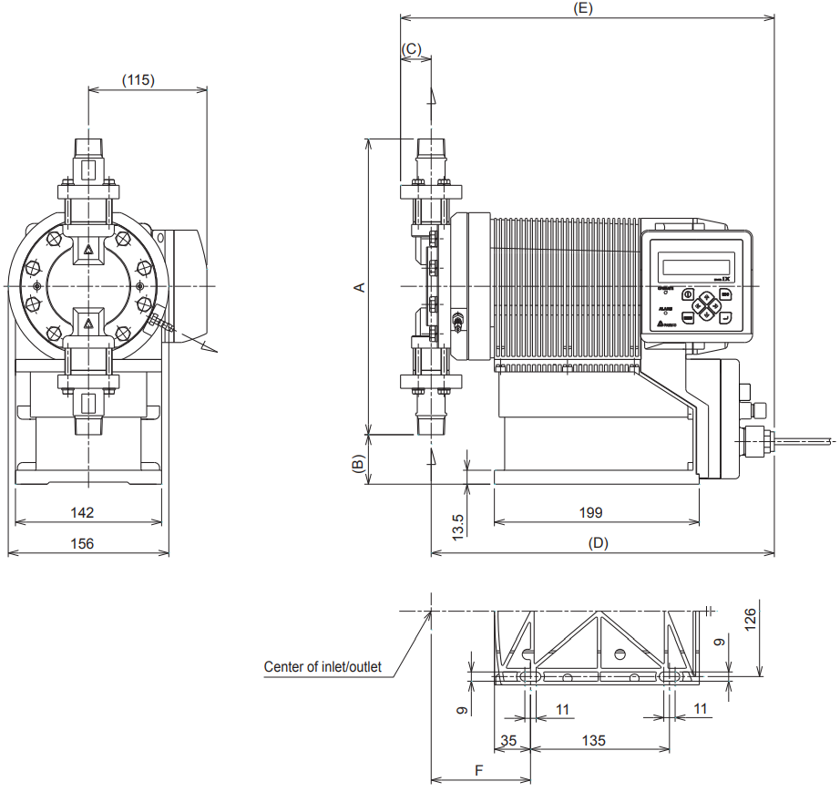
■ IX-(C060/C150)
S6 N

TB Mounting

RF Mounting

 | A | B | C | D | E | F
IX-C060 | 335 | 25 | - | 340 | - | 103
IX-C150 | 317 | 34 | - | 339 | - | 102
All dimensions are in mm

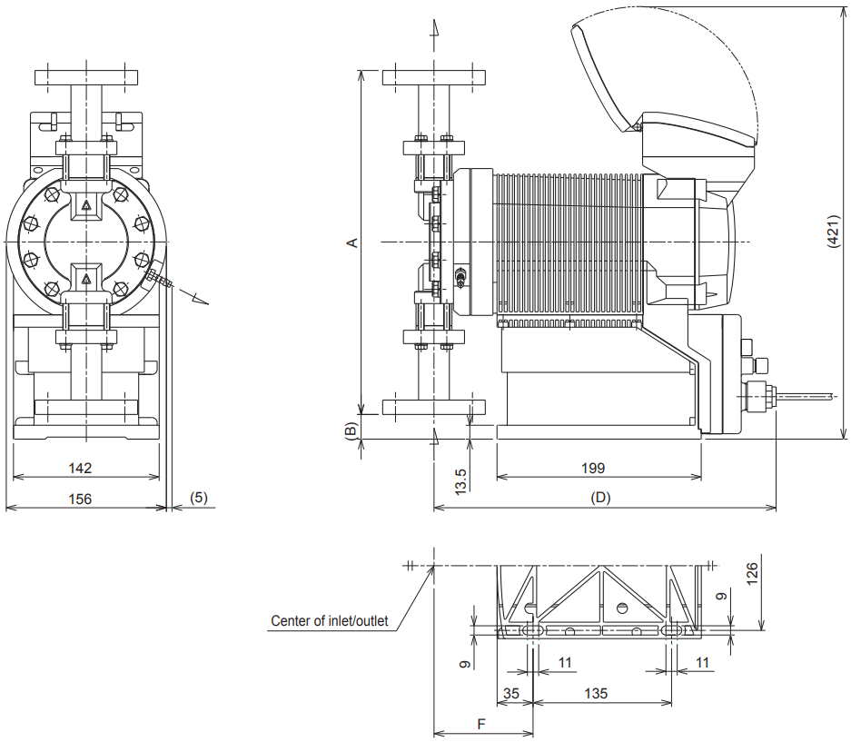
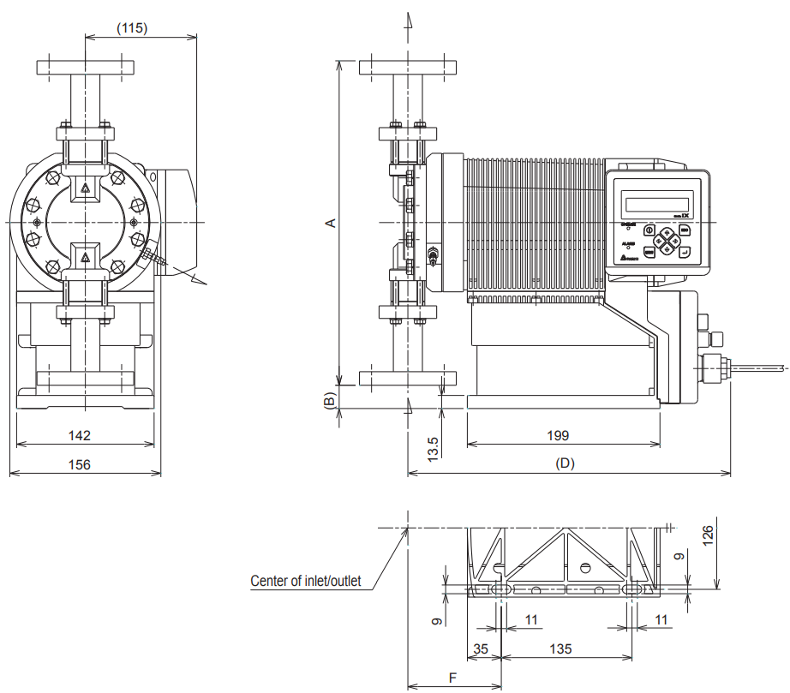
■ IX-(C060/C150)
S6 FA

TB Mounting

RF Mounting

 | A | B | C | D | E | F
IX-C060 | 270 | 57 | - | 339 | - | 102
IX-C150 | 335 | 24 | - | 334 | - | 97
All dimensions are in mm
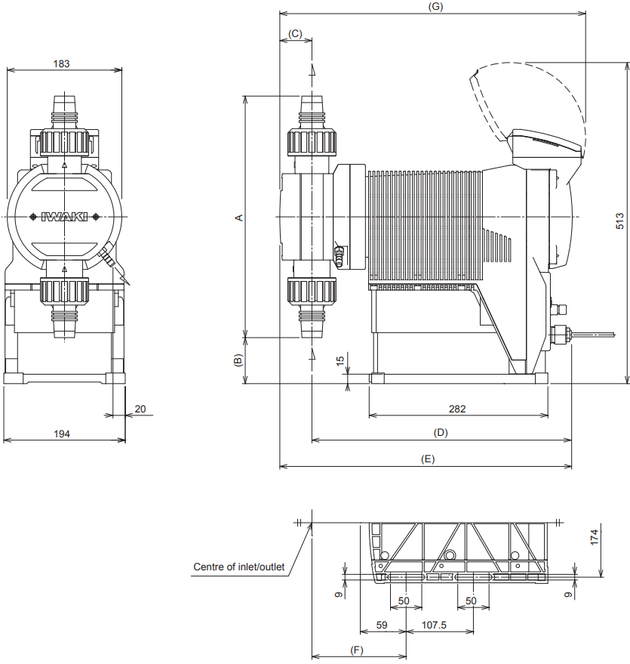
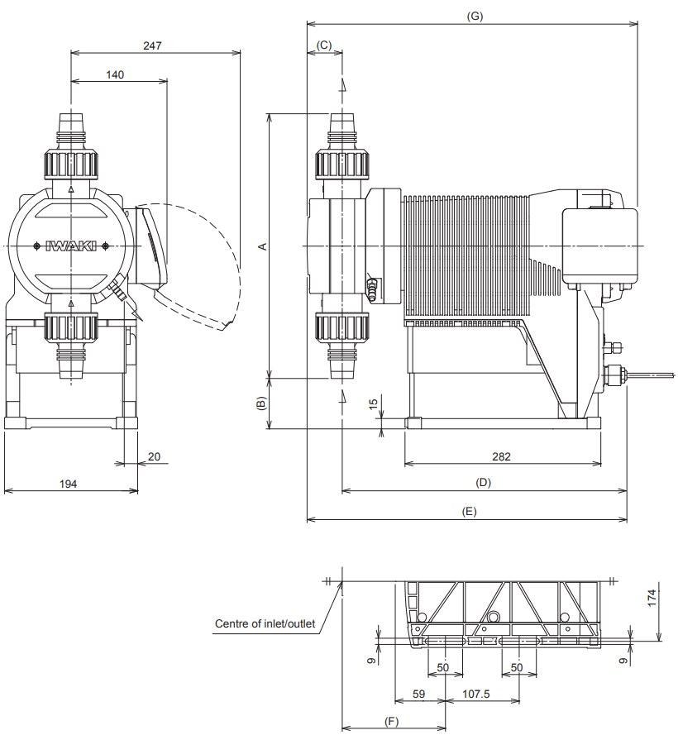
TB Mounting

RF Mounting
■ IX-(D150/D300)
(TC/TE) N

 | A | B | C | D | E | F | G
IX-D150 | 317 | 108 | 42 | 409 | 450 | 144 | 465
IX-D300 | 384 | 74 | 52 | 415 | 467 | 151 | 482
All dimensions are in mm
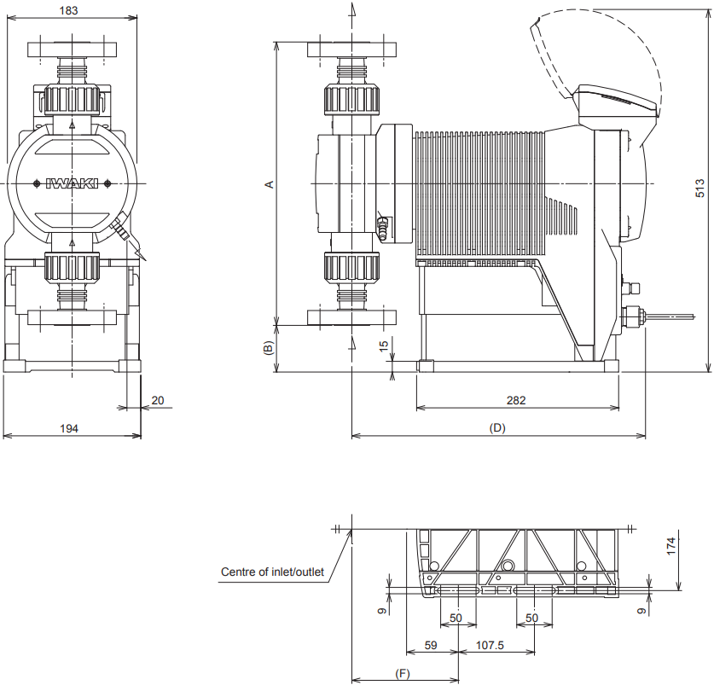
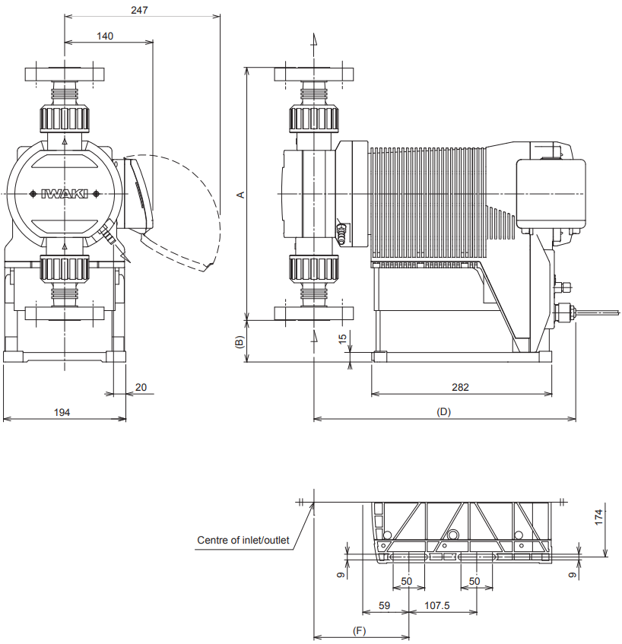
TB Mounting

RF Mounting
■ IX-(D150/D300)
(TC/TE) FA

 | A | B | C | D | E | F | G
IX-D150 | 340 | 97 | - | 409 | - | 144 | -
IX-D300 | 383 | 74 | - | 415 | - | 151 | -
All dimensions are in mm
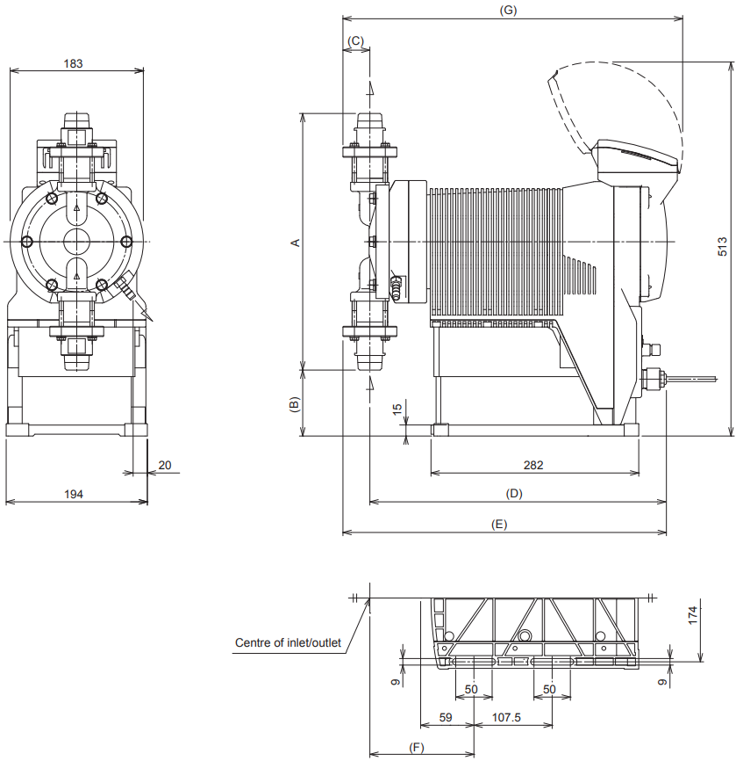
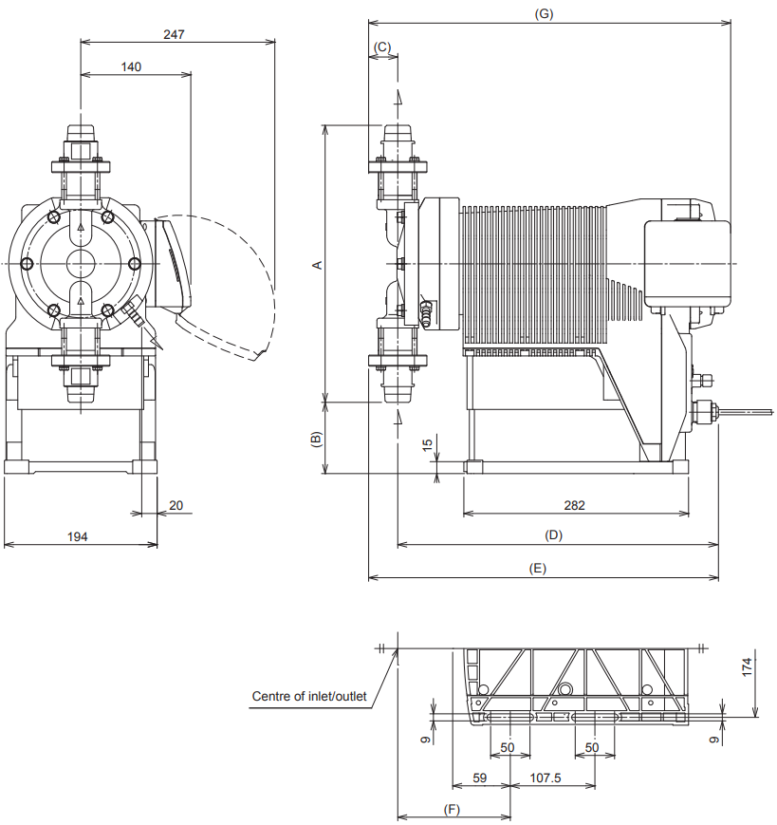
TB Mounting

RF Mounting
■ IX-(D150/D300)
S6 N

 | A | B | C | D | E | F | G
IX-D150 | 315 | 108 | 30 | 401 | 431 | 136 | 460
IX-D300 | 355 | 88 | 37 | 408 | 445 | 143 | 467
All dimensions are in mm
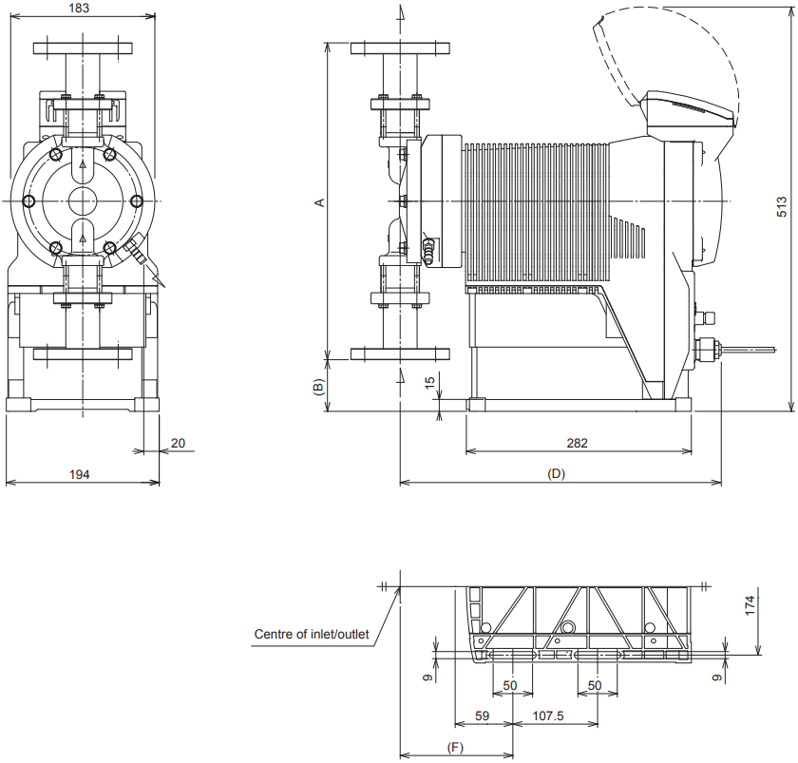
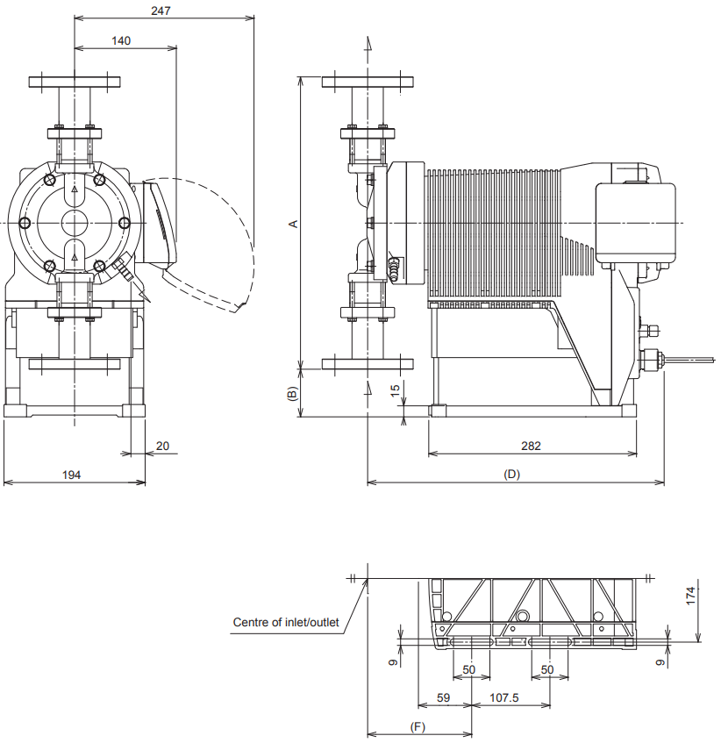
TB Mounting

RF Mounting
■ IX-(D150/D300)
S6 FA

 | A | B | C | D | E | F | G
IX-D150 | 363 | 84 | - | 401 | - | 136 | -
IX-D300 | 405 | 63 | - | 408 | - | 143 | -
All dimensions are in mm

