WDB400 Series

Blowdown and Feed Boiler Conductivity Controllers

For Two Boilers

180449.C Revised 5/23/2012

Part 1. General

1.1 Scope

A. This section describes the requirements for a blowdown and feed conductivity controller for two boilers with automatically temperature compensated electrodes.

B. Under this item, the contractor shall furnish and install the conductivity control equipment and accessories as indicated on the plans and as herein specified.

1.2 Submittals

A. The following information shall be included in the submittal for this section:
1. Data sheets and catalog literature for a microprocessor based blowdown and feed conductivity controller for two boilers and electrodes.
2. Interconnection and dimensional drawings.
- List of spare parts

Part 2. Products

2.1 Blowdown and feed boiler conductivity controller

A. The blowdown and feed boiler conductivity control system shall consist of a control module that provides on/off conductivity control, chemical feed, and conductivity electrodes that provide measurement of the conductivity, as well as a temperature measurement for automatic compensation for errors due to temperature fluctuations.

B. Control Module:
- Enclosure: Polycarbonate, NEMA 4X, lockable hinged door with clear window.
- Power: 100-240 VAC, 50/60 Hz, 8A, Fuse: 1.0 ampere, 5 x 20 mm
- Inputs:
- Conductivity (two): 0 to 10,000 μS/cm.
- Temperature (two): Pt1000
- No Flow Interlock (two): Isolated dry contact closure (reed switch)
- Water meter contactor (two): Isolated dry contact closure (reed switch).

- Outputs:
- Control (on/off): Four internally powered relays
6A resistive, 1/8 HP. All relays must be fused together as one group, total current for this group must not exceed 6A
- 4 – 20 mA (One or two optional): Fully isolated, internally powered, 600 ohm maximum resistive load.

- Software features:
- Control relays shall feature adjustable control direction and dead band.
- Intermittent sampling shall be selectable.
- If intermittent sampling has been selected, then a control strategy that detects and compensates for flashing shall be implemented.
- Chemical feed shall be selectable from blowdown and feed, feed as a percentage of blowdown, feed as a percentage of time, and feed based on a water meter contactor input.
- If chemical feed through the controller is not desired, those relays may be selected to function as high/low alarm relays.
- A self test shall be available to verify the integrity of the control module’s sensor input circuitry.
- Manual activation of the relays shall be easily accomplished via the keypad.
- A maximum output on-time shall be available on both relays to prevent runaway control.
- The diagnostic alarm relay shall be activated by a number of error conditions.
- Software upgrade file shall be transferable to the controller via a USB memory stick.
- Optional data log of conductivity, temperature, and water meter totals in 10 minute increments over a two-month period.
- Optional event log with time-stamped relay on/off and flow/no flow events.
- Optional configuration file import/export feature.

C. Sensor:
- Operating Principle: The conductivity sensor shall be driven with a low voltage AC signal, and the return signal voltage will vary with the conductivity of the intervening solution.

The Pt1000 temperature signal shall also be delivered to the control module, in order to automatically compensate for sensor errors due to temperature fluctuations.

- Materials of construction: 316SS, PEEK or PVDF.

- Process connections: 3/4” NPTM sensor thread
- Temperature range: 0 – 200 degrees C.
- Pressure range: 0 – 250 psig.

D. Controller and Sensor Performance
- Range: 0 – 10,000 μS/cm.
- Accuracy: From 10-10,000 μS/cm ± 1% of reading; from 0-10 μS/cm ± 20% of reading.
- Resolution: ± 1μS/cm.
4. Maximum separation between the controller and the sensor shall be 250 feet.

E. Indication
- Graphic User Interface
- A 2 line x 16 character backlit LCD display shall indicate the process values, and the status of outputs and alarms.
- Four LED lamps shall indicate the on/off status of the control outputs.

F. Equipment
The blowdown and feed boiler conductivity controller shall be a Walchem WDB400 series.

Part 3. Operator Functions

3.1 Calibration

- The conductivity electrode calibration shall be a one point calibration, utilizing a solution of a known conductivity.

- All set points shall be set through the 8 button keypad.

- An access code shall be available to protect all set points and calibrations, while allowing the user to view any set point.

3.2 Control Module Function Details

- The conductivity control output shall be on/off control with adjustable dead band.

- The conductivity control direction shall be selected via the keypad.

- The chemical feed output shall be on/off control with four choices of feed modes.

- All control relays shall have limit timers to prevent runaway control.

Part 4. Execution

4.1 Installation

A. The sensors shall be installed in the skimmer line that draws a sample from 4-6 inches below the lowest possible boiler water level.

B. The sensors shall be installed in a pipe with no flow restrictions between the boiler water and the sensor.

C. The distance between the sensors and the boiler water shall be as short as possible.

D. The sample provided must be water, not steam. Back pressure must be provided by a flow control valve or orifice union located downstream from the sensor.

E. The sensor cables shall be routed such that they are separated from any AC voltage by at least 6 inches.

- If the sensor cables need to be extended beyond the standard 10 feet, then 24 AWG, 2 twisted pair, shielded cable shall be utilized, to a maximum of 500 ft.

- If the optional 4 – 20 mA output(s) is installed, then 22-26 AWG, twisted pair, shielded cable shall be utilized.

Part 5. Warranty

5.1 Terms

A. The manufacturer of the above specified equipment shall guarantee equipment of its manufacture, and bearing its identification to be free from defects in workmanship and material for a period of 24 months for electronics and 12 months for mechanical parts from date of delivery from the factory or authorized distributor under normal use and service and otherwise when such equipment is used in accordance with instructions furnished by the manufacturer and for the purposes disclosed in writing at the time of purchase, if any.

B. In the event a component fails to perform as specified and having been returned to the manufacturer transportation charges prepaid, and is proven defective in service during the warranty period, the manufacturer shall repair or replace the defective part. Replaceable elastomeric parts and glass components are expendable and are not covered by any warranty.

Part 6. Options

6.1 Related Equipment

- Orifice Union for back pressure and blowdown rate control
- Solenoid valve for blowdown control
- EZB16D1-VC metering pump for chemical feed
- Motorized ball valve for blowdown control
- 100084 Sensor extension cable

Part 7. Spare Parts

7.1 Recommended Spare Parts

- 103163 Fuse, 1 A, 250 VAC

B. 102864 Fuse, 6 A, 250 VAC

Specifications

Measurement Performance |  | Mechanical
Conductivity: |  | Enclosure |  | Polycarbonate
Range | 0-10,000 µS/cm | NEMA rating |  | NEMA 4X
Resolution | 1 µS/cm | Dimensions |  | See next page
Accuracy | 10-10,000 μS/cm ±1% of reading  0-10 μS/cm ±20% of reading | Display |  | 2 x 16 character backlit liquid crystal
Temperature: |  | Ambient Temp |  | 32 to 158°F (0 to 70°C)
Range | 32 to 392° (0 to 200°) | Storage Temp. |  | -20 to 180°F(-29 to 80°C)
Resolution | 0.1°C | Shipping Weight |  | 10 lbs (approximately)
Accuracy | ±1% of reading
Inputs |  | Outputs
Power | 100-240 VAC, 50/60 Hz, 8A  Fuse: 1.0 ampere, 5 x 20 mm | Mechanical relays | Five powered relays  6 A (resistive), 1/8 HP  All relays are fused together as one group, total current for this group must not exceed 6A
Signal | Cond Electrode: 1.0 cell factor, 10K thermistor | Mechanical relays
 | Flow Meter (optional): Isolated, dry contact closure required (i.e. relay, reed switch)  Flow Switch (optional): Isolated, dry contact closure required (i.e. reed switch) | 4-20 mA  (optional) | Fully isolated, internally powered,  600Ω maximum resistive load.  Resolution, .001% of span, accuracy ±1% of reading

Dimensions

WIRING DETAILS
A AC POWER, 8 AMPS MAX
2 x 28 AWG PLUS GROUND OR LOCAL
CODE
B AC POWER, 6 AMPS MAX
SOLENOID, ALARM OR METERING PUMP
2 x 18 AWG PLUS GROUND OR LOCAL
CODE
C AC POWER, 6 AMPS MAX
MOTORIZED BALL VALVE
3 x 18 AWG PLUS GROUND OR LOCAL
CODE
D CONDUCTIVITY ELECTRODE
4 x 24 AWG PLUS SHIELD, 10 FT SUPPLIED
E OPTIONAL 4-20mA OUTPUT
2 x 24 AWG PLUS SHIELD

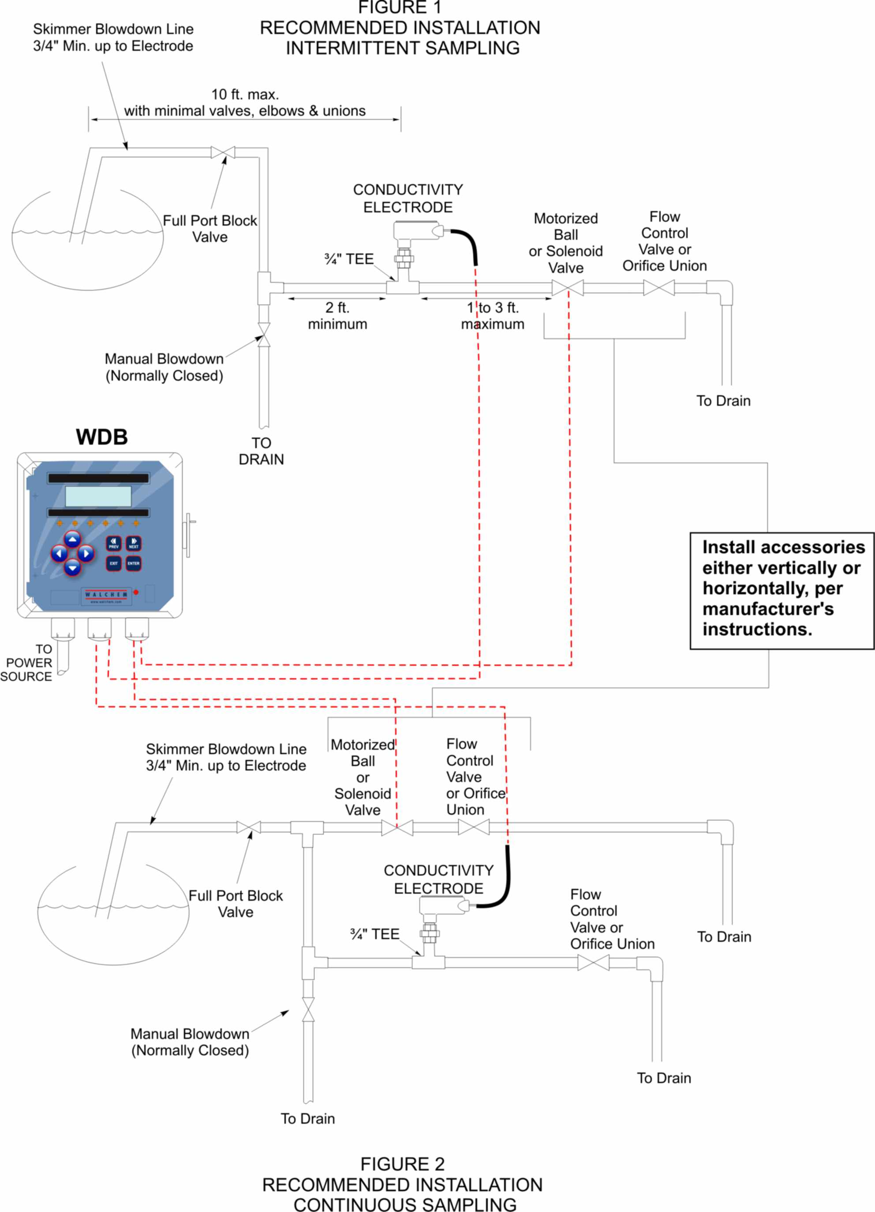
WIRING DETAILS

A AC POWER, 8 AMPS MAX
2 x 28 AWG PLUS GROUND OR LOCAL CODE

B AC POWER, 6 AMPS MAX
SOLENOID, ALARM OR METERING PUMP
2 x 18 AWG PLUS GROUND OR LOCAL CODE

C AC POWER, 6 AMPS MAX
MOTORIZED BALL VALVE
3 x 18 AWG PLUS GROUND OR LOCAL CODE

D CONDUCTIVITY ELECTRODE
4 x 24 AWG PLUS SHIELD, 10 FT SUPPLIED

E OPTIONAL 4-20MA OUTPUT
2 x 24 AWG PLUS SHIELD

Ordering Information

WDB400-

(Voltage) (Output) (Sensor) (USB)

VOLTAGE
1 = 120 VAC, prewired
5 = 100-240 VAC, conduit

OUTPUT
N = No data output
4 = Isolated 4-20 mA output
2 = Two isolated 4-20 mA outputs

SENSOR
N = No electrodes
5 = Standard electrodes (up to 250 psi)

USB FEATURES
N = Software upgrade capability only

U = Integrated datalogging, event/reset logging, and configuration file import/export

Safety Approvals

Agency Approvals
UL | ANSI/UL 61010-1:2004, 2nd Edition*
CAN/CSA | C22,2 No.61010-1:2004 2nd Edition*
CE Safety | EN 61010-1:2001 2nd Edition *
CE EMC | EN 61326-1:2006
Note: For EN61000-4-6, EN61000-4-3 the controller met performance criteria B.
*Class A equipment: Equipment suitable for use in establishments other than domestic, and those directly connected to a low voltage (100-240 VAC) power supply network which supplies buildings used for domestic purposes.

WDB INPUTS

WDB OUTPUTS

WDB WIRING

